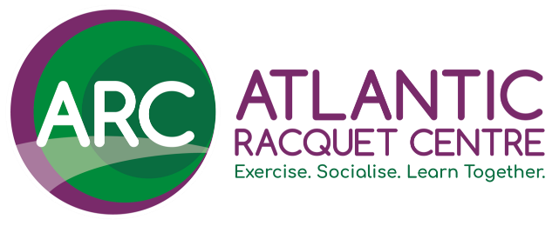
VOLUNTEERING AT ARC
#JoinTheTeam
YOUR DETAILS:
Full Name:
Nickname/ Preferred Name:
Home Address:
Email Address:
Phone Number:
Date of Birth:

TELL US A BIT MORE ABOUT YOU:
Which volunteer role(s) are you applying for? (Please circle)
Welcome Team Member  Cleaning Team Member  Session Activator  Any - I’m happy to do whichever  role you think suits me best |  | Coaching Assistant  Play Maker  Grounds & Maintenance Team Member  Other (_________________________)
Why are you interested in volunteering at ARC? (Please circle all that apply)
To develop my skills/ knowledge  To have fun/enjoyment  To feel useful  To fill some spare time  To get fitter/ get some exercise  To support ARC and the work it does |  | To get some work experience or improve my CV  To help others  To make a difference to the local community  To spend time with like-minded people  To use my skills
Other (Please specify):
What skills & experience do you think you can bring to the role?
E.g previous work roles, communication skills, knowledge of the sport etc.
When would you be available to volunteer? (Please circle all that apply)
Weekday Evenings  Weekend Evenings  None of the above |  | Weekday Daytime  Weekend Daytime
How many hours per week would you like to commit to volunteering at ARC?
(Please circle)
1 – 3 hours  3 – 6 hours |  | 6 – 9 hours  10+ hours
Please let us know if you have any particular requirements or health conditions that we should be aware of:
Are you legally allowed to volunteer in the UK? (Please circle)
YES |  | NO
Do you have any convictions which are unspent under the Rehabilitation of Offenders Act 1974?
YES |  | NO
Please provide us with the names and contact details of two referees.
REFEREE 1 |  | REFEREE 2
Name: |  | Name:
Relationship to you: |  | Relationship to you:
Email Address: |  | Email Address:
Phone Number: |  | Phone Number:

Equal Opportunities (OPTIONAL SECTION)
We are committed to volunteering being open and accessible to all. To help us
with this, it would be great if you could answer a few more questions about yourself. You don’t have to complete this, but in doing so you will help us understand whether we can do more to be relevant to everyone.
We will treat this information as strictly confidential. It will only be used for monitoring purposes and not used or referred to as part of the recruitment process.
What gender do you identify as?
How would you describe your ethnic origin?
Do you consider yourself to have a disability, as defined by the Equality Act 2012?
How would you describe your sexual orientation?
Please describe your religious group

SUBMITTING YOUR APPLICATION
Thank you for completing your application to join the ARC Volunteer Team. If you are happy that all the information provided above is true and complete, please sign below.

Please note that you must be available for one of induction dates shown on the role description document.
.
SIGNED:
PRINT NAME:
DATE:
Please send you completed application form to Tom Vinall via one of the following:
VIA EMAIL TO: | tom@atlanticracquetcentre.co.uk
VIA POST TO: | Tom Vinall, Atlantic Racquet Centre, Farm Road, Caddsdown Industrial Estate, Bideford, Devon. EX39 3BE.

